**SUPPLEMENTARY SECTION**

**Seroprevalence of Hepatitis B, C and D in Vietnam: a systematic review and meta-analysis**

**TLRHWESTERNPACIFIC-D-22-00076**

**SEARCH STRATEGY**

**PubMed:**

Free text advanced search: ‘Hepatitis B‘ OR ‘Hepatitis C’ OR ‘Hepatitis D’ AND ‘Vietnam’ AND ‘Prevalence’ with date filter 1990 – 2021 elicits 327 results.

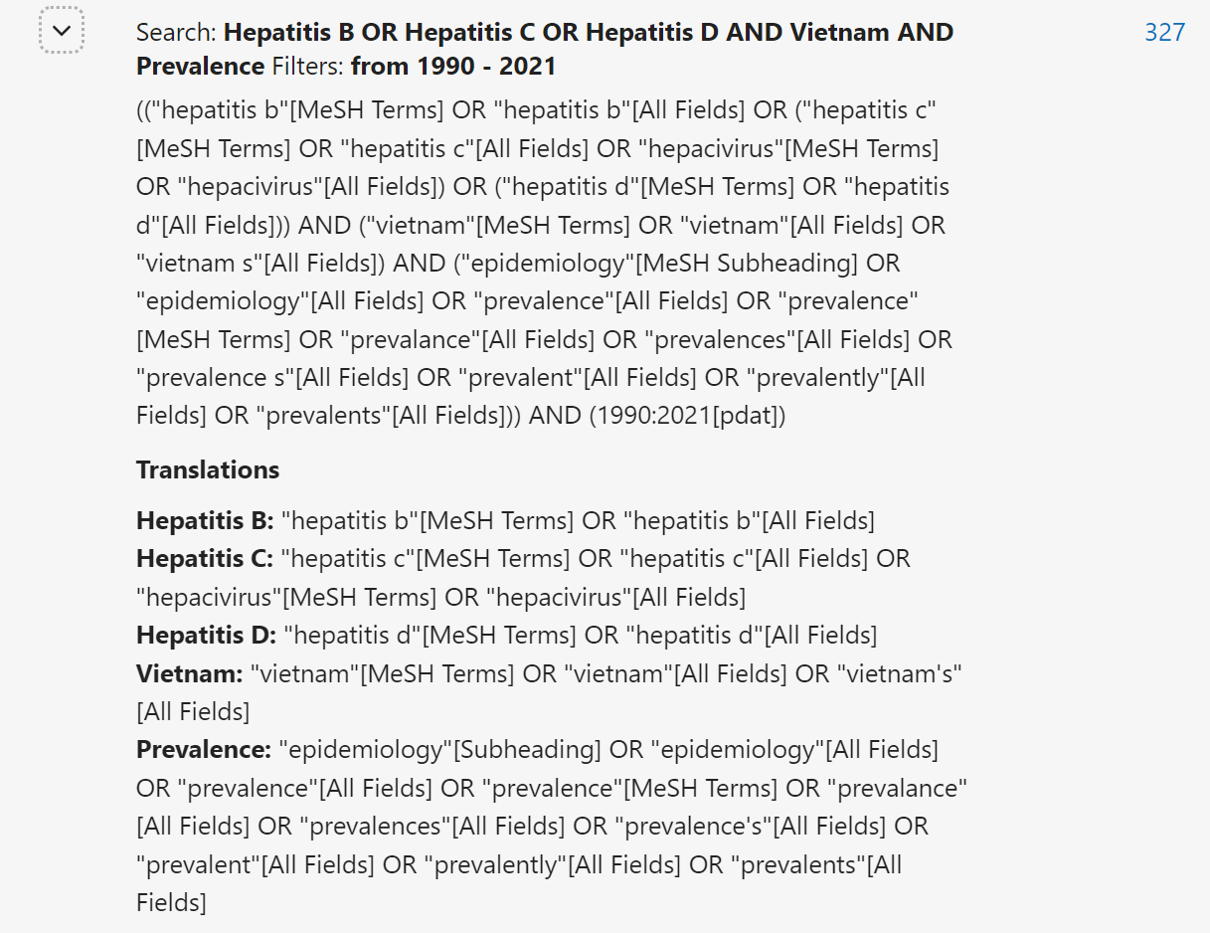

Embase:

Free text advanced search ‘Hepatitis B‘ OR ‘Hepatitis C’ OR ‘Hepatitis D’ AND ‘Vietnam’ AND ‘Prevalence’ with date filter 1990 – 2021 in Embase Classic+Embase (1947 to 2022 March 11), Global Health (OVID) (1973 to 2022 Week 10)



**Full titles of included studies**

**Table S1: Hepatitis B studies (n=44)**

|  |  |
| --- | --- |
| **Title** | **Author** |
| Short report: hepatitis B infection and severe Plasmodium falciparum malaria in Vietnamese adults | Barcus et al 2002 |
| Prevalence of hepatitis A, B, C and E virus markers among patients with elevated levels of Alanine aminotransferase and Aspartate aminotransferase in Phnom Penh (Cambodia) and Nha Trang (Central Vietnam) [French] | Buchy et al 2004 |
| Malaria in injection drug abusers in Vietnam | Chau et al 2002 |
| Sexual practices, partner concurrency and high rates of sexually transmissible infections among male sex workers in three cities in Vietnam | Clatts et al 2015 |
| Viral infections and chemical exposures as risk factors for hepatocellular carcinoma in Vietnam | Cordier et al 1993 |
| Acute viral hepatitis in Hanoi, Viet Nam | Corwin et al 1996 |
| High prevalences of hepatitis B and C virus infections among adults living in Binh Thuan province, Vietnam | Do et al 2015 |
| A multicentre molecular analysis of hepatitis B and blood-borne virus coinfections in Viet Nam | Dunford et al 2012 |
| Risk factors for hepatitis B infection in rural Vietnam | Duong et al 2009 |
| Hepatitis B and C virus infections among patients with end stage renal disease in a low-resourced hemodialysis center in Vietnam: a cross-sectional study | Duong et al 2015 i |
| Challenges of hemodialysis in Vietnam: experience from the first standardized district dialysis unit in Ho Chi Minh City | Duong et al 2015 ii |
| Shewhart Charts and Two-Monthly Screening Interval to Monitor Hepatitis C and Hepatitis B Virus Infections in Two-Year Prospective Cohort Study of Hemodialysis Patients in Vietnam | Duong et al 2016 |
| Clinical and biological characteristics of HIV infected and uninfected IDUs in HCMC vietnam | Follezou et al 1999 |
| Prevalence of and Factors Associated with Reproductive Tract Infections among Pregnant Women in Ten Communes in Nghe An Province, Vietnam | Goto et al 2005 |
| Hepatitis B infection in rural Vietnam and the implications for a national program of infant immunization | Hipgrave et al 2003 |
| Impact of a methadone maintenance therapy pilot in Vietnam and its role in a scaled-up response | Hoang et al 2015 |
| Discrepancies in prevalence trends for HIV, hepatitis B virus, and hepatitis C virus in Haiphong, Vietnam from 2007 to 2012 | Ishizaki et al 2017 |
| Prevalence of hepatitis B, hepatitis C and GB virus C /hepatitis G virus infections in liver disease patients and habitants in HCM vietnam | Kakumu et al 1998 |
| Seroprevalence of hepatitis viruses in children in rural Viet Nam | Katelaris et al 1995 |
| Impact of Nucleic Acid Testing (NAT) on screening blood donors at a tertiary center in Vietnam | Kha To et al 2020 |
| Reproductive tract infections including sexually transmitted infections: a population-based study of women of reproductive age in a rural district of Vietnam | Lan et al 2008 |
| Epidemiology of hepatitis C virus infection in Vietnam. [French] | Lien et al 1997 |
| High hepatitis C virus infection among female sex workers in Viet Nam: strong correlation with HIV and injection drug use | Linh-Vi et al 2019 |
| The Prevalence and Components of Metabolic Syndrome in Men from Infertile Couples and Its Relation on Semen Analysis | Minh et al 2021 |
| Hepatitis B virus infection among pregnant mothers and children after the introduction of the universal vaccination program in Central Vietnam | Miyakawa et al 2021 |
| Findings from Integrated Behavioral and Biologic Survey among males who inject drugs (MWID)-Vietnam, 2009-2010: Evidence of the need for an integrated response to HIV, hepatitis B virus, and hepatitis C virus | Nadol et al 2015 |
| High hepatitis C virus (HCV) prevalence among men who have sex with men (MSM) in Vietnam and associated risk factors: 2010 Vietnam Integrated Behavioural and Biologic Cross-Sectional Survey | Nadol et al 2016 |
| Hepatitis C and B virus infections in populations at low or high risk in Ho Chi Minh and Hanoi, Vietnam | Nakata et al 1994 |
| High rates of positeve viral hepatitis serologic in patients attending a city hospital challenge healthcare providers | Ngo et al 2009 |
| The impact of dengue haemorrhagic fever on liver function | Nguyen et al 1997 |
| Highly endemic hepatitis B infection in rural Vietnam | Nguyen et al 2006 |
| Prevalence of HBV infection among different HIV-risk groups in Hai Phong, Vietnam | Nguyen et al 2011 |
| A reduction in chronic hepatitis B virus infection prevalence among children in Vietnam demonstrates the importance of vaccination | Nguyen et al 2014 |
| High burden of hepatocellular carcinoma and viral hepatitis in Southern and Central Vietnam: Experience of a large tertiary referral center, 2010 to 2016 | Nguyen-Dinh et al 2018 |
| Hepatitis B Infection and Mother-to-Child Transmission in Haiphong, Vietnam: A Cohort Study with Implications for Interventions | Pham et al 2020 |
| Prevalence and factors associated with chronic Hepatitis B infection among adults in the Central Highland, Vietnam | Pham et al 2020 ii |
| Risks for HIV, HBV, and HCV infections among male injection drug users in northern Vietnam: A case-control study | Quan et al 2009 |
| Markers of hepatitis C and B virus infections among blood donors in Ho Chi Minh City and Hanoi, Vietnam. | Song et al 1994 |
| Prevalence of hepatitis B and hepatitis C in healthy adults in Ho Chi Minh City | Terakawa et al 2011 |
| Baseline Characteristics and Treatment Cost of Hepatitis C at Hospital for Tropical Diseases, Ho Chi Minh City, Vietnam in Direct-Acting Antiviral Treatment Era | Thanh et al 2020 |
| Liver involvement associated with dengue infection in adults in Vietnam | Trung et al 2010 |
| Hepatits B in Ho Chi Minh City, Viet Nam | Van Be et al 1992 |
| Epidemiological Characteristics of Advanced Hepatocellular Carcinoma in the Northern Region of Vietnam | Van Quang Le et al 2019 |
| Prevalence of hepatitis B & hepatitis C virus infections in potential blood donors in rural Vietnam. | Viet et al 2012 |

**Table S2: Hepatitis C studies (n=44)**

|  |  |
| --- | --- |
| **Title** | **Author** |
| Prevalence of hepatitis A, B, C and E virus markers among patients with elevated levels of Alanine aminotransferase and Aspartate aminotransferase in Phnom Penh (Cambodia) and Nha Trang (Central Vietnam) [French] | Buchy et al 2004 |
| Malaria in injection drug abusers in Vietnam | Chau et al 2002 |
| Prevalence and incidence of HCV infection among Vietnam heroin users with recent onset of injection | Clatts et al 2009 |
| HIV, Hepatitis C, and Other Sexually Transmitted Infections Among Male Sex Workers in Ho Chi Minh City, Vietnam | Colby et al 2016 |
| Viral infections and chemical exposures as risk factors for hepatocellular carcinoma in Vietnam | Cordier et al 1993 |
| Acute viral hepatitis in Hanoi, Viet Nam | Corwin et al 1996 |
| High prevalences of hepatitis B and C virus infections among adults living in Binh Thuan province, Vietnam | Do et al 2015 |
| Hepatitis C virus in Vietnam: high prevalence of infection in dialysis and multi-transfused patients involving diverse and novel virus variants | Dunford et al 2012 |
| Hepatitis B and C virus infections among patients with end stage renal disease in a low-resourced hemodialysis center in Vietnam: a cross-sectional study | Duong et al 2015 i |
| Challenges of hemodialysis in Vietnam: experience from the first standardized district dialysis unit in Ho Chi Minh City | Duong et al 2015 ii |
| Shewhart Charts and Two-Monthly Screening Interval to Monitor Hepatitis C and Hepatitis B Virus Infections in Two-Year Prospective Cohort Study of Hemodialysis Patients in Vietnam | Duong et al 2016 |
| Risk Behaviors for HIV and HCV Infection Among People Who Inject Drugs in Hai Phong, Viet Nam, 2014 | Duong et al 2018 |
| Screening haemodialysis patients for hepatitis C in Vietnam: The inconsistency between common hepatitis C virus serological and virological tests | Duong et al 2019 |
| Clinical and biological characteristics of HIV infected and uninfected IDUs in HCMC vietnam | Follezou et al 1999 |
| Impact of a methadone maintenance therapy pilot in Vietnam and its role in a scaled-up response | Hoang et al 2015 |
| Discrepancies in prevalence trends for HIV, hepatitis B virus, and hepatitis C virus in Haiphong, Vietnam from 2007 to 2012 | Ishizaki et al 2017 |
| Prevalence of hepatitis B, hepatitis C and GB virus C /hepatitis G virus infections in liver disease patients and habitants in HCM vietnam | Kakumu et al 1998 |
| Seroprevalence of hepatitis viruses in children in rural Viet Nam | Katelaris et al 1995 |
| Impact of Nucleic Acid Testing (NAT) on screening blood donors at a tertiary center in Vietnam | Kha To et al |
| Epidemiology of hepatitis C virus infection in Vietnam. [French] | Lien et al 1997 |
| High hepatitis C virus infection among female sex workers in Viet Nam: strong correlation with HIV and injection drug use | Linh-Vi et al 2019 |
| HIV control programs reduce HIV incidence but not HCV incidence among people who inject drugs in HaiPhong, Vietnam | Molès et al 2020 |
| Findings from Integrated Behavioral and Biologic Survey among males who inject drugs (MWID)-Vietnam, 2009-2010: Evidence of the need for an integrated response to HIV, hepatitis B virus, and hepatitis C virus | Nadol et al 2015 |
| High hepatitis C virus (HCV) prevalence among men who have sex with men (MSM) in Vietnam and associated risk factors: 2010 Vietnam Integrated Behavioural and Biologic Cross-Sectional Survey | Nadol et al 2016 |
| Findings from Integrated Behavioral and Biologic Survey among males who inject drugs (MWID)-Vietnam, 2009-2010: Evidence of the need for an integrated response to HIV, hepatitis B virus, and hepatitis C virus | Nadol et al 2016 |
| Hepatitis C and B virus infections in populations at low or high risk in Ho Chi Minh and Hanoi, Vietnam | Nakata et al 1994 |
| Lack of association between acquisition of TT virus and risk behavior for HIV and HCV infection in Vietnam | Nerurkar et al 1999 |
| High rates of positeve viral hepatitis serologic in patients attending a city hospital challenge healthcare providers | Ngo et al 2009 |
| The impact of dengue haemorrhagic fever on liver function | Nguyen et al 1997 |
| Prevalence and risk factors for hepatitis C infection in rural north vietnam | Nguyen et al 2007 |
| Acceptability and Usability of HCV Self-Testing in High Risk Populations in Vietnam | Nguyen et al 2021 |
| High burden of hepatocellular carcinoma and viral hepatitis in Southern and Central Vietnam: Experience of a large tertiary referral center, 2010 to 2016 | Nguyen-Dinh et al 2018 |
| Risks for HIV, HBV, and HCV infections among male injection drug users in northern Vietnam: A case-control study | Quan et al 2009 |
| Hepatitis C virus seroprevalence in the general female population from 8 countries | Quesada et al 2015 |
| Towards Targeted Interventions in Low- and Middle-Income Countries: Risk Profiles of People Who Inject Drugs in Haiphong (Vietnam) | Riondel et al 2020 |
| The evolution of hepatitis C in the kidney transplant recipient at CHO ray hospital | Sinh et al 2012 |
| Markers of hepatitis C and B virus infections among blood donors in Ho Chi Minh City and Hanoi, Vietnam. | Song et al 1994 |
| Multiple routes of hepatitis C virus transmission among injection drug users in Hai Phong, Northern Vietnam | Tanimoto et al 2010 |
| Prevalence of hepatitis B and hepatitis C in healthy adults in Ho Chi Minh City | Terakawa et al 2011 |
| Prevalence of hepatitis virus types B through E and genotypic distribution of HBV and HCV in Ho Chi Minh City, Vietnam | Tran et al 2003 |
| Liver involvement associated with dengue infection in adults in Vietnam | Trung et al 2010 |
| Epidemiological Characteristics of Advanced Hepatocellular Carcinoma in the Northern Region of Vietnam | Van Quang et al 2019 |
| Prevalence of hepatitis B & hepatitis C virus infections in potential blood donors in rural Vietnam. | Viet et al 2012 |
| Prevalence and correlates of HCV monoinfection and HIV and HCV coinfection among persons who inject drugs in Vietnam | Zhang et al 2015 |

**Table S3: HIV studies with HBV or HCV co-infection data (n=10)**

|  |  |
| --- | --- |
| **Title** | **Author** |
| TAHOD-LITE: Antiretroviral Treatment for Adult HIV Infection in Asia, 1998 to 2013 | Boettiger et al 2015 |
| HBV and HCV Coinfection among HIV/AIDS Patients in the National Hospital of Tropical Diseases, Vietnam | Bùi et al 2014 |
| Prevalence of Opportunistic Infections and Associated Factors in HIV-Infected Men Who Have Sex With Men on Antiretroviral Therapy in Bach Mai Hospital, Hanoi, Vietnam: A Case-Control Study | Dang et al 2020 |
| Epidemiology of hepatitis C virus infection in Vietnam. [French] | Lien et al 1997 |
| Viral hepatitis among HIV+ patients in northern Vietnam | Mohan et al 2017 |
| High Proportion of HIV-HCV Coinfected Patients with Advanced Liver Fibrosis Requiring Hepatitis C Treatment in Haiphong, Northern Vietnam (ANRS 12262) | Nguyen et al 2016 |
| Factors associated with HIV RNA viral loads in ART-naive patients: implications for treatment as prevention in concentrated epidemics | Rangarajan et al 2016 |
| Penicilliosis and AIDS in Haiphong, Vietnam: evolution and predictive factors of death | Son et al 2014 |
| Long-term viral suppression and immune recovery during first-line antiretroviral therapy: a study of an HIV-infected adult cohort in Hanoi, Vietnam | Tanuma et al 2017 |

**Table S4: HDV studies (n=7)**

|  |  |
| --- | --- |
| **Title** | **Author** |
| HDV infection rates in northern Vietnam | Binh et al 2018 |
| A multicentre molecular analysis of hepatitis B and blood-borne virus coinfections in Viet Nam | Dunford et al 2012 |
| High prevalence of hepatitis delta virus among persons who inject drugs, Vietnam | Hall et al 2015 |
| Predominance of HBV Genotype B and HDV Genotype 1 in Vietnamese Patients with Chronic Hepatitis | Nghiem et al 2021 |
| Prevalence and genotype distribution of hepatitis delta virus among chronic hepatitis B carriers in Central Vietnam | Nguyen et al 2017 |
| High prevalence and significance of hepatitis D virus infection among treatment-naive HBsAg-positive patients in Northern Vietnam | Sy et al 2013 |
| Prevalence of hepatitis virus types B through E and genotypic distribution of HBV and HCV in Ho Chi Minh City, Vietnam | Tran et al 2003 |

**Table S5:** **Joanna Briggs Institute (JBI) critical appraisal checklist for prevalence data for all 72 included studies**

Critical appraisal of study quality was performed by BF (first author) and HVTK (third author). Discrepancies regarding study eligibility were resolved through discussion between investigators (HVTK, BF).

1. Was the sample frame appropriate to address the target population?
2. Were study participants recruited in an appropriate way?
3. Was the sample size adequate?
4. Were the study subjects and setting described in detail?
5. Was data analysis conducted with sufficient coverage of the identified sample?
6. Were valid methods used for the identification of the condition?
7. Was the condition measured in a standard, reliable way for all participants?
8. Was there appropriate statistical analysis?
9. Was the response rate adequate, and if not, was the low response rate managed appropriately?

|  |  |  |  |  |  |  |  |  |  |  |  |
| --- | --- | --- | --- | --- | --- | --- | --- | --- | --- | --- | --- |
| **Study** | **JBI checklist indicators** | | | | | | | | | **Score** | **Comment** |
|  | 1 | 2 | 3 | 4 | 5 | 6 | 7 | 8 | 9 |  |  |
| Barcus et al 2002 | No | No | Yes | Yes | Yes | Yes | Yes | Yes | Yes | 7 | Non-random consecutive sampling, non- representative sample (severe malaria) |
| Binh et al 2018 | No | No | Yes | Yes | Yes | Yes | Yes | Yes | Yes | 7 | Non-random consecutive sampling, non-representative sample (85% male) |
| Boettiger et al 2015 | Yes | No | Yes | Yes | Yes | Yes | Yes | Yes | Yes | 8 | Non-random consecutive sampling |
| Buchy et al 2004 | Yes | No | No | Yes | Yes | Yes | Yes | Yes | Yes | 7 | Non-random consecutive sampling, underpowered |
| Bùi et al 2014 | Yes | No | Yes | Yes | Yes | Yes | Yes | Yes | Yes | 8 | Non-random; entire centre’s population |
| Chau et al 2002 | No | Yes | Yes | Yes | Yes | Yes | Yes | Yes | Yes | 8 | Non-random consecutive sampling |
| Clatts et al 2009 | No | Yes | Yes | Yes | Yes | Yes | Yes | Yes | Yes | 8 | Non-random sampling; non-representative sample (male IVDU only) |
| Clatts et al 2015 | No | Yes | Yes | Yes | Yes | Yes | Yes | Yes | Yes | 8 | Non-random; non-representative (sex workers) |
| Colby et al 2016 | No | Yes | Yes | Yes | Yes | Yes | Yes | Yes | Yes | 8 | Non-random sampling; non-representative (sex workers) |
| Cordier et al 1993 | No | Yes | Yes | Yes | Yes | Yes | Yes | Yes | Yes | 8 | Non-random, non-representative, male HCC only |
| Corwin et al 1996 | Yes | No | Yes | Yes | Yes | Yes | Yes | Yes | Yes | 8 | Non-random consecutive sampling |
| Dang et al 2020 | Yes | No | Yes | Yes | Yes | Yes | Yes | Yes | Yes | 8 | Non-random consecutive sampling |
| Do et al 2015 | Yes | Yes | No | Yes | Yes | Yes | Yes | Yes | Yes | 8 | Multi-stage cross-sectional |
| Dunford et al 2012 | Yes | No | Yes | Yes | Yes | Yes | Yes | Yes | Yes | 8 | Non-random consecutive sampling |
| Dunford et al 2012 | Yes | No | Yes | Yes | Yes | Yes | Yes | Yes | Yes | 8 | Non-random consecutive sampling |
| Duong et al 2009 | No | Yes | Yes | Yes | Yes | Yes | Yes | Yes | Yes | 8 | Cross sectional but non-representative rural sample |
| Duong et al 2015 i | Yes | No | Yes | Yes | Yes | Yes | Yes | Yes | Yes | 8 | Non-random consecutive sampling |
| Duong et al 2015 ii | Yes | No | Yes | Yes | Yes | Yes | Yes | Yes | Yes | 8 | Non-random consecutive sampling |
| Duong et al 2016 | Yes | No | Yes | Yes | Yes | Yes | Yes | Yes | Yes | 8 | Non-random; entire centre population |
| Duong et al 2018 | Yes | No | Yes | Yes | Yes | Yes | Yes | Yes | Yes | 8 | Non-random consecutive sampling |
| Duong et al 2019 | Yes | No | Yes | Yes | Yes | Yes | Yes | Yes | Yes | 8 | Non-random; entire centre population |
| Follezou et al 1999 | No | No | Yes | Yes | Yes | Yes | Yes | Yes | Yes | 6 | Non-representative sample (very high rates HIV) |
| Goto et al 2005 | Yes | No | Yes | Yes | Yes | Yes | Yes | Yes | Yes | 8 | Non-random consecutive sampling |
| Hall et al 2015 | Yes | No | Yes | No | Yes | Yes | Yes | Yes | Yes | 7 | Non-random consecutive sampling, lacks baseline characteristics |
| Hipgrave et al 2003 | Yes | Yes | Yes | Yes | Yes | Yes | Yes | Yes | Yes | 9 |  |
| Hoang et al 2015 | Yes | No | Yes | Yes | Yes | Yes | Yes | Yes | Yes | 8 | Non-random consecutive sampling |
| Ishizaki et al 2017 | Yes | No | Yes | Yes | Yes | Yes | Yes | Yes | Yes | 8 | Non-random consecutive sampling |
| Kakumu et al 1998 | Yes | No | Yes | Yes | Yes | Yes | Yes | Yes | Yes | 8 | Non-random consecutive sampling of hepatitis patients. Details of sampling strategy for general popualtion lacking |
| Katelaris et al 1995 | Yes | Yes | No | Yes | Yes | Yes | Yes | Yes | Yes | 8 | Under powered for HCV prevalence |
| Kha To et al 2020 | Yes | No | Yes | Yes | Yes | Yes | Yes | Yes | Yes | 8 | Non-random consecutive sampling |
| Lan et al 2008 | No | Yes | Yes | Yes | Yes | Yes | Yes | Yes | Yes | 8 | Non-representative sample (married women age 18-49) |
| Lien et al 1997 | Yes | No | Yes | Yes | Yes | Yes | Yes | Yes | Yes | 8 | Non-cross sectional sampling |
| Linh-Vi et al 2019 | Yes | Yes | Yes | Yes | Yes | Yes | Yes | Yes | Yes | 9 |  |
| Minh et al 2021 | No | No | Yes | Yes | Yes | Yes | Yes | Yes | Yes | 7 | Non-random, non-representative sample (males from infertile couples) |
| Miyakawa et al 2021 | Yes | No | Yes | Yes | Yes | Yes | Yes | Yes | No | 7 | Non-random sample, high drop out >30% |
| Mohan et al 2017 | Yes | No | Yes | Yes | Yes | Yes | Yes | Yes | Yes | 8 | Non-random retrospective chart review |
| Molès et al 2020 | Yes | No | Yes | Yes | Yes | Yes | Yes | Yes | Yes | 8 | Non-random response-driven sampling |
| Nadol et al 2015 | Yes | No | Yes | Yes | Yes | Yes | Yes | Yes | Yes | 8 | Non-random response-driven sampling |
| Nadol et al 2016 | Yes | No | Yes | Yes | Yes | Yes | Yes | Yes | Yes | 8 | Non-random response-driven sampling |
| Nakata et al 1994 | Yes | No | Yes | Yes | Yes | Yes | Yes | Yes | Yes | 8 | Non-random consecutive and retrospective sampling |
| Nerurkar et al 1999 | Yes | No | Yes | Yes | Yes | No | Yes | Yes | Yes | 7 | Non-random sampling, diagnostics were combo of sera or filter paperblotted whole blood |
| Nghiem et al 2021 | Yes | No | Yes | Yes | Yes | Yes | Yes | Yes | Yes | 8 | Non-random, consecutive sampling |
| Ngo et al 2009 | No | No | Yes | No | Yes | Yes | Yes | Yes | Yes | 6 | Non-random, consecutive sampling, non-representative sample (inpatients and outpatients), minimal baseline characteristics |
| Nguyen et al 1997 | No | No | No | Yes | Yes | Yes | Yes | Yes | Yes | 6 | Non-random consecutive sampling, non-representative sample (patients with severe Dengue), under-powered for HCV |
| Nguyen et al 2006 | Yes | Yes | Yes | Yes | Yes | Yes | Yes | Yes | Yes | 9 |  |
| Nguyen et al 2007 | Yes | Yes | Yes | Yes | Yes | Yes | Yes | Yes | Yes | 9 |  |
| Nguyen et al 2011 | Yes | No | Yes | Yes | Yes | Yes | Yes | Yes | Yes | 8 | Non-random consecutive sampling |
| Nguyen et al 2014 | Yes | Yes | Yes | Yes | Yes | Yes | Yes | Yes | Yes | 9 |  |
| Nguyen et al 2017 | No | No | Yes | Yes | Yes | Yes | Yes | Yes | Yes | 7 | Non-random consecutive sampling, non- representative |
| Nguyen-Dinh et al 2018 | Yes | No | Yes | Yes | Yes | Yes | Yes | Yes | Yes | 8 | Non-random sampling, Oraquick diagnostics |
| Pham et al 2020 | Yes | Yes | Yes | Yes | Yes | Yes | Yes | Yes | Yes | 9 | Non-random retrospective sample |
| Pham et al 2020 ii | Yes | Yes | Yes | Yes | Yes | Yes | Yes | Yes | Yes | 9 |  |
| Quan et al 2009 | Yes | No | Yes | Yes | Yes | Yes | Yes | Yes | Yes | 8 |  |
| Quesada et al 2015 | No | Yes | Yes | Yes | Yes | Yes | Yes | Yes | Yes | 8 | Non-random snowball sampling using peer recruiters |
| Rangarajan et al 2016 | Yes | No | Yes | Yes | Yes | Yes | Yes | Yes | Yes | 8 | Non-representative sample (females only) |
| Riondel et al 2020 | Yes | No | Yes | Yes | Yes | Yes | Yes | Yes | Yes | 8 | Non-random consecutive sampling |
| Sinh et al 2012 | Yes | No | Yes | No | Yes | Yes | Yes | Yes | Yes | 7 | Non-random response-driven sampling |
| Son et al 2014 | No | No | No | Yes | Yes | Yes | Yes | Yes | Yes | 6 | Non-random consecutive sample, lacking baseline characteristics |
| Song et al 1994 | Yes | No | Yes | Yes | Yes | Yes | Yes | Yes | Yes | 8 | Non-random consecutive sampling, non-representative (inpatients with penicilliosis), under powered for HBV/HCV prevalence |
| Sy et al 2013 | No | No | Yes | Yes | Yes | Yes | Yes | Yes | Yes | 8 | Non-random sampling |
| Tam et al 2016 | Yes | No | Yes | Yes | Yes | Yes | Yes | Yes | Yes | 8 | Non-random consecutive sampling, non-representative (HCV and HIV positive patients excluded) |
| Tanimoto et al 2010 | Yes | No | Yes | Yes | Yes | Yes | Yes | Yes | Yes | 8 | Non-random response driven sampling |
| Tanuma et al 2017 | Yes | No | Yes | Yes | Yes | Yes | Yes | Yes | Yes | 8 | Non-random consecutive sampling |
| Terakawa et al 2011 | No | No | Yes | Yes | Yes | Yes | Yes | Yes | Yes | 7 | Non-random sampling, non-representative (healthy workers at major companies) |
| Thanh et al 2020 | No | No | Yes | Yes | Yes | Yes | Yes | Yes | Yes | 7 | Non-random consecutive sample, non-representative (HCV-infected outpatients) |
| Tran et al 2003 | No | No | Yes | Yes | Yes | Yes | Yes | Yes | Yes | 7 | Non-random sampling, non-representative (healthy outpatients) |
| Truong et al 2016 | No | No | Yes | Yes | Yes | Yes | Yes | Yes | Yes | 7 | Non-random consecutive sample |
| Trung et al 2010 | No | Yes | Yes | Yes | Yes | Yes | Yes | Yes | Yes | 8 | Non-random consecutive sampling |
| Van Be et al 1992 | No | No | Yes | No | Yes | Yes | Yes | Yes | Yes | 6 | Non-random sampling, unclearly defined study populations, no basseline characteristics |
| Van Quang et al 2019 | Yes | No | Yes | Yes | Yes | Yes | Yes | Yes | Yes | 8 | Non-random, restrospective sample |
| Viet et al 2012 | No | No | Yes | Yes | Yes | Yes | Yes | Yes | Yes | 7 | Non-random sampling; non-representative (*potential* blood donors, HBV-vaccinated individuals excluded) |
| Zhang et al 2015 | Yes | No | Yes | Yes | Yes | Yes | Yes | Yes | Yes | 8 | Non-random sampling |

**Figure S1: study populations by location**

**Table S6: Studies reporting HCV antibody and HCV antigen or HCV RNA in same population**

|  |  |  |  |
| --- | --- | --- | --- |
| **Study** | **Population** | **Proportion of HCV antibody positive individuals with HCV RNA or antigen** | **95% C.I.** |
| Duong et al 2019 | Dialysis | 100% | [71.5 - 100] |
| Tanimoto et al 2010 | PWID | 79.30% | [74.4 – 83.6] |
| Kakumu et al 1998 | Liver disease | 60.90% | [48.3 – 72.4] |
| Le et al 2019 | CSW | 58.50% | [52.4 – 64.4] |
| Do et al 2015 | General population | 50.00% | [26.0 – 74.0] |
| Kakumu et al 1998 | General population | 44.40% | [13.70 - 78.8] |

**Figure S2:** estimated pooled HCV antibody prevalence in PWID by region

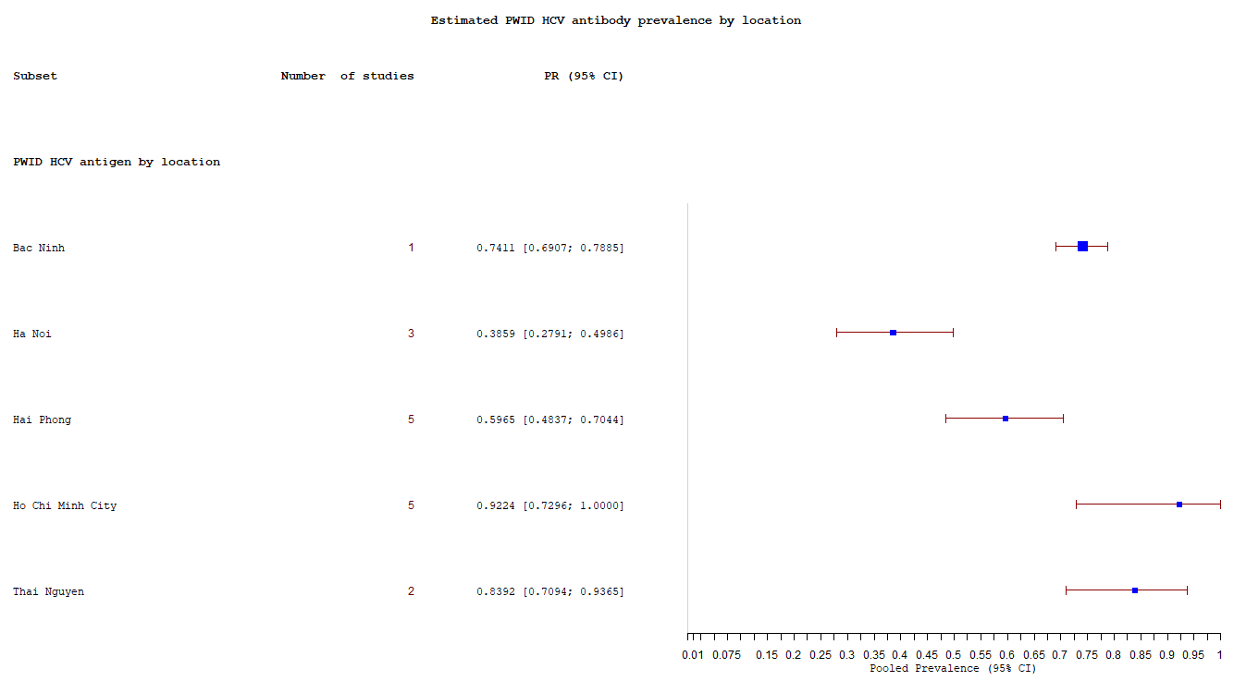

**Figure S3:** estimated pooled HCV antigen prevalence in PWID by region

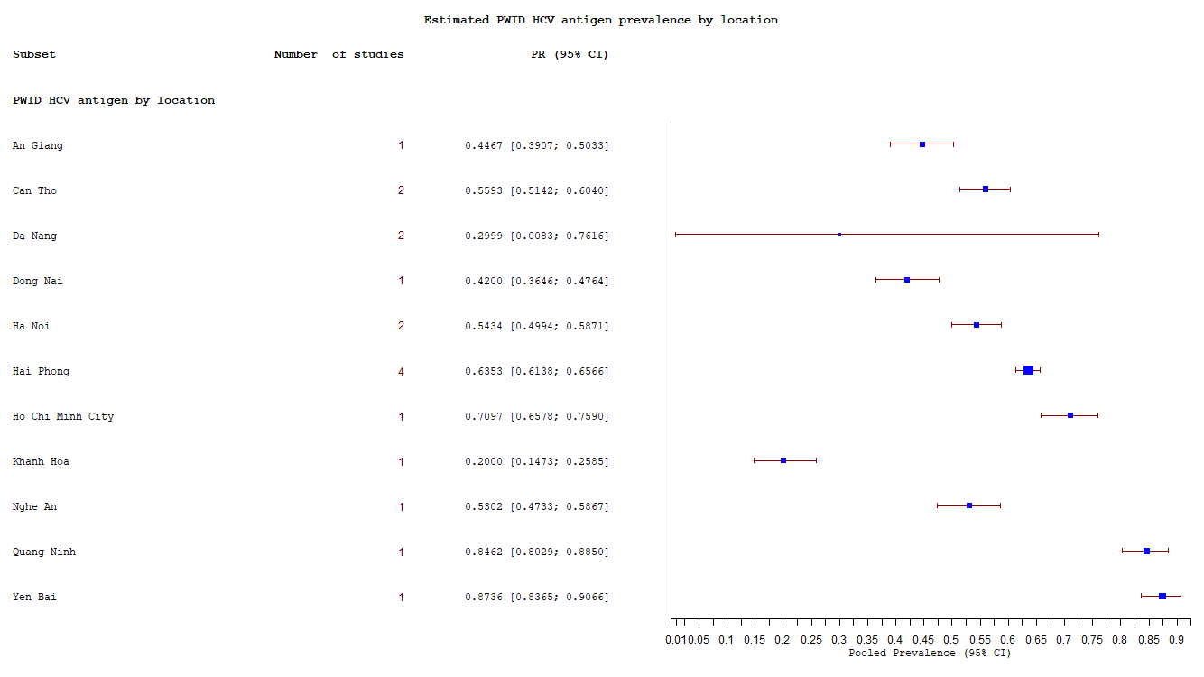

**END OF DOCUMENT**